

|  |
| --- |
| **Project Document** |
| **Car Rental Service Website** |

|  |  |
| --- | --- |
| **Group 1** | |
| **Group Members** | **Hoang Anh - C2010G0141**  **Vu Duc Anh - C2108L0272**  **Nguyen Dinh Duy  - C2105L0183**  **Pham Dang Duc - C2108L0255**  **Nguyen Trung Duc - C2108L0265** |
| **Supervisor** | **Dao Quang Linh** |
| **Project code** | **CRSW** |

**- Hanoi, 12/2023 -**

**Table of Contents**

Acknowledgement 4

Definition and Acronyms 4

**1** **Project Introduction 5**

1.1 Project Information 5

1.2 Project Team 5

1.3 Product Background 5

1.4 Existing Systems 5

1.5 The proposed system 5

1.6 Project Scope & Limitations 5

**2** **Project Management Plan 6**

2.1 The purpose and target of a project 6

2.2 Management Approach 6

2.3 Responsibility Assignments 7

2.4 Project Communications 7

2.5 Project Work Plan 7

2.6 Configuration Management 7

**3** **Software Requirement Specification 8**

3.1 User Requirements 8

3.2 Functional Requirements 9

3.3 Non-Functional Requirements 10

3.4 Other Requirements… 10

**4** **Software Design Description 11**

4.1 1. System Design 11

4.2 2. Database Design 11

4.3 3. Detailed Design 11

**5** **Software Testing Documentation 12**

5.1 1. Scope of Testing 12

5.2 2. Test Strategy 12

5.3 3. Test Plan 12

5.4 4. Test Cases 12

5.5 5. Test Reports 12

**6** **Release Package & User Guides 13**

6.1 1. Deliverable Package 13

6.2  2. Installation Guides 13

# **Acknowledgement**

During the time of studying, we have well provided and imparted all the necessary and highly valuable professional knowledge by our teacher in Aptech. We have our faithful, careful style and creative mind in studying in the future.

Project is a good opportunity to apply appropriate knowledge and subjects. While performing projects, we have actual and valuable experience. After one term, we were getting all one’s thoughts together and working on a project. During executing this project, we have received a lot of helping from our guider, teachers.

Especially, we wish to thank our teacher - Mr: Dao Quang Linh - for his enthusiastic, thoughtful, and careful guidance.

# **Project Introduction**

## **Project Information**

Nowadays, we are living in an era of peace, where everything is progressing. As a result, the demand for travel is increasing day by day. Whether it's for business trips, tourism, commuting, or transporting goods, the need for long-distance travel is evident. To cover such distances efficiently, having a car becomes essential, saving both time and effort.

However, for purposes like occasional travel or long-distance business trips, investing in a car might seem extravagant and not everyone may have the financial means to do so. Coupled with the technological boom of the current period, we have developed a website to facilitate online car rental. Users can easily select the vehicle they desire for rent, and those with unused cars have the opportunity to generate additional income by offering them for rent. This initiative not only addresses the need for convenient transportation but also taps into the sharing economy, promoting accessibility and flexibility in the usage of automobiles.

* **Project Information**
* Project Name (English): Car Rental Service Website
* Project Name (Vietnamese): Ứng dụng website dịch vụ cho thuê xe ô tô
* Project Code: CRSW
* Project Type: Web API Project
* Timeline: From 27th September to 8th November

## **Project Team**

## **Supervisor**

|  |  |  |
| --- | --- | --- |
| **Full name** | **Phone Number** | **Email** |
| Đào Quang Linh | 0976 678 404 | linh.dq@aptechlearning.edu.vn |

## **Team member**

|  |  |  |  |  |
| --- | --- | --- | --- | --- |
| **Full name** | **Roll number** | **Position** | **Phone Number** | **Email** |
| Hoàng Anh | C2010G0141 | Member | 0988869520 | anh.h.953@aptechlearning.edu.vn |
| Vũ Đức Anh | C2108L0272 | Member | 0975502334 |  |
| Nguyễn Đình Duy | C2105L0183 | Leader | 0368415649 | duy.nd.1849@aptechlearning.edu.vn |
| Phạm Đăng Đức | C2108L0255 | Member | 0704125993 | duc.pd.1930@aptechlearning.edu.vn |
| Nguyễn Trung Đức | C2108L0265 | Member | 0836710765 | duc.nt.1940@aptechlearning.edu.vn |

## **Product Background**

* For each person and each family, a car is not only a means of transportation but also a major family asset and not every family can afford it. Not only that, some families, although well-off and able to buy a car, still choose to use self-driving car rental services because it brings many conveniences.
* Nowadays, car prices are increasing very rapidly, compared to the average income of each person, owning a car is very difficult. Based on the news website (https://baotintuc.vn), car prices in 2023 have increased 2.5 times compared to the market price of previous years, leading to workers gradually shifting to renting self-driving cars. According to Mordor Intelligence, the self-driving car rental market in Vietnam is valued at 463.19 million USD in 2021, and is expected to reach 884.71 million USD in 2027 with a compound annual growth rate of 13.82% in the period 2022 - 2027. Meanwhile, according to Statista, the revenue of the self-driving car rental market in Vietnam in 2023 is expected to reach 0.92 billion USD. In addition, the revenue of this market is expected to reach 1.19 billion USD by 2027 with a compound annual growth rate of 6.57% in the period 2023 - 2027.

## **Existing Systems**

* We have some overviews of similar existing solutions, overview of existing methods, limitations of some existing applications.
* Avis.com

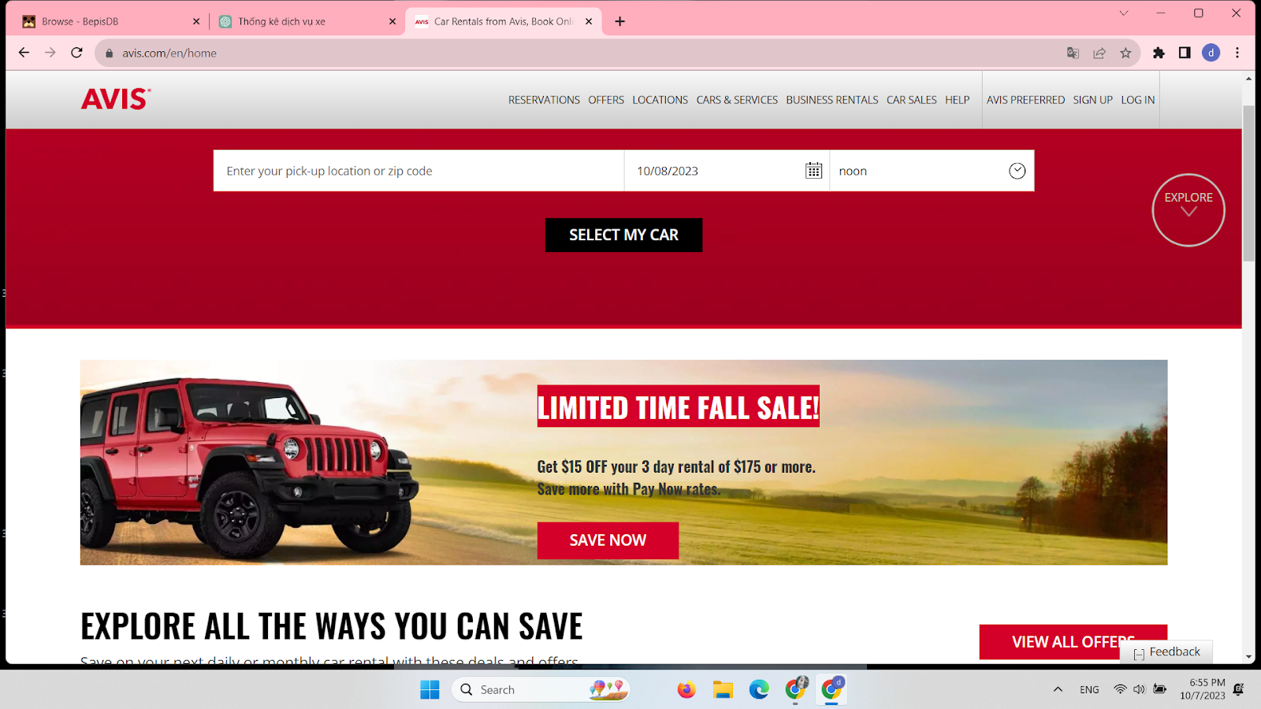

|  |  |
| --- | --- |
| Pros:   * Easy to use. * Support for search owners’s names; informations of owners, car….; times-setting * Personalized. * Information is accurate and reliable. | Cons:   * Users and car owners must download apps from the web to fill in their necessary information. * The interface is rough and looks unfriendly * No support Vietnamese |

* Xego.vn

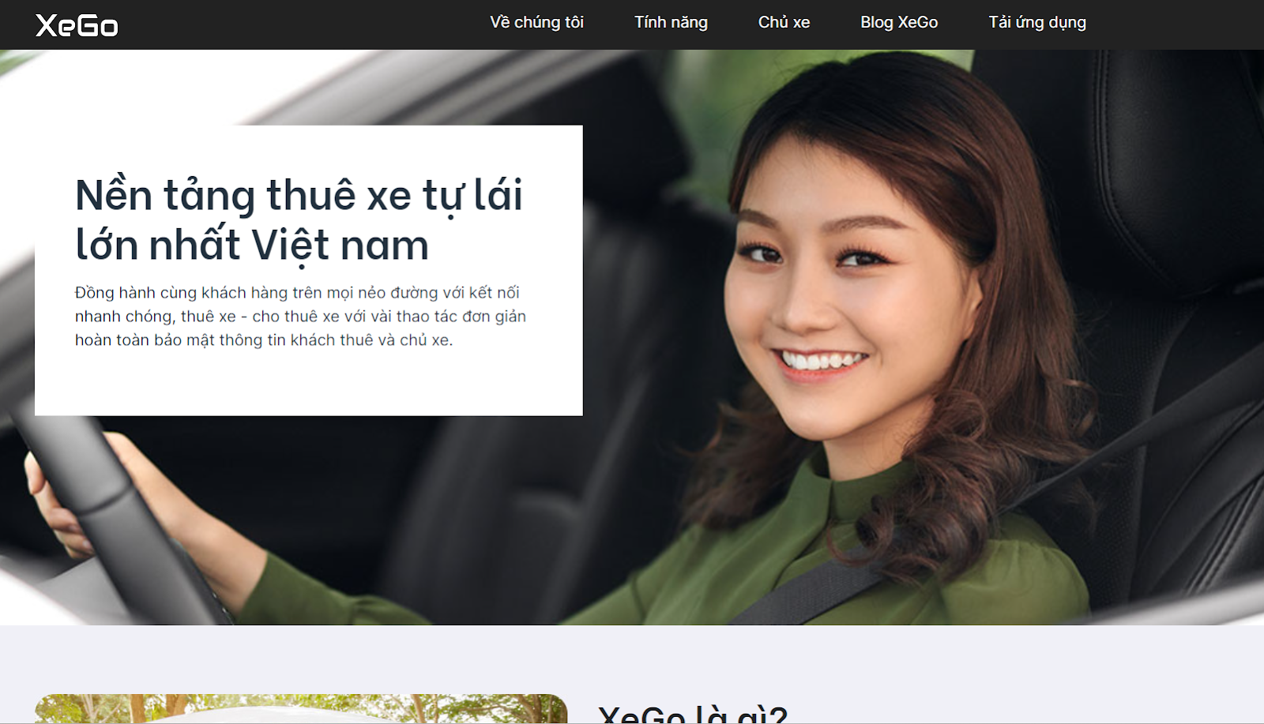

|  |  |
| --- | --- |
| Pros:   * Personalized. * Information is accurate and reliable. * Support Vietnamese | Cons:   * Users and car owners must download app of web to fill in their necessary informations. * Less informations. |

## **The proposed system**

* Online car rental service is a step forward from traditional car rental service. Although building an online car rental service has overcome many limitations of traditional services, the number of car rental websites with a user-friendly interface on the web is not many. The avis.com and xego.vn websites, as listed as examples, are among the largest service websites in this field, but there are still limitations related to personal information registration. In the immediate future, we want to create a website that has the function to fill in important information of individual car renters and owners. Besides, we want the website to have a convenient, user-friendly interface.
* The application will have functions to help users in their work most effectively. Functions such as:   
   1. **Display images and information of rented vehicles** -> help customers and users access a variety of models and types of vehicles that customers want instead of the limited number of models compared to traditional car rentals.  
   2. **Convenient and proactive** -> help customers and users proactively plan and book calendars at any time and in the most comfortable position.  
   3. **Reputation and quality** -> the app is an intermediary that accurately verifies both the customer and the owner of the rental car. Become a tool to ensure the quality and transparency of car leases and vehicle documents.  
   4. **Safety and privacy** -> legal support application, including customer support teams and vehicle owners when issues related to the agreement between the two parties occur.  
   5. **Reviews** -> show reviews of users to provide information to customers and consumers so that they can make wise rental/purchase decisions and have a comprehensive review of the product

## **Project Scope & Limitations**

**About our project scope:**

* **Consumer demand**
  + Help users and customers who want to rent self-driving cars access the service easily, flexibly and conveniently.
  + Create a platform that seamlessly connects the person who needs to rent a car with the owner of the rental car.
  + Become a tool to help car rental owners easily manage, do business, access more customer files.
* **Conditions and feasibility of the project:**
  + The project has a low investment, minimizes costs, helps users not to pay any additional fees from the website
  + The demand of customers in the market is high, the application has many opportunities to reach users
* **Limitations**
  + The website requires a stable internet connection to launch smoothly.
  + The website does not have an accompanying mobile application.
  + Verifying documents takes time and requires precise operations as instructed.

# **Project Management Plan**

## **The purpose and target of a project**

## **Project Objectives**

* This report is a guide to regulation and supervision of organization and plan of the project. It describes an overview of the project including the proposed system, boundaries and development environment of the capstone project. The ultimate purpose of Project management plan is to clearly deﬁne the roles, responsibilities and the processes of team members to assign tasks and deadlines.

## **Project Risks ( Risk Breakdown Structure (RBS) )**

|  |  |  |  |  |
| --- | --- | --- | --- | --- |
| Probability | Impact | | | |
|  | Low | Medium | High |
| Low | Risk 7, Risk 8, Risk 10 | Risk 9 | Risk 4 |
| Medium | Risk 5 | Risk 3 |  |
| High |  | Risk 1 | Risk2 |

|  |  |  |  |  |
| --- | --- | --- | --- | --- |
| ID | Description | First Indicator | Prevention  Approach | Mitigation  Approach |
| 1 | Team members are spaced apart | * Teamwork’s efficiency decrease. * Hard to coordinate team members. * It is difficult for group members to meet each other | * Make the plan as detailed as possible, use milestones, who does the work set the estimate. * Frequently update project plan. | - When the deadline is delayed, overtime is needed. |
| 2 | Lack of equipment and machinery for the project | * Slow down the completion of tasks * Difficulty sharing information and plans of the project * Unable to do work handed over |  |  |
| 3 | Hemorrhagic fevers | * Due to the epidemic, some team members have health problems. * Unable to continue the work, progress was delayed. |  |  |
| 4 | Trapped in a traffic accident. There are relatives who are in critical condition and in poor health. | * Unable to be present for group discussions, financial issues, limited time * Minimize ideas, ability to work, cause panic |  |  |
| 5 | Inactive Email Account | * The account provided by the school has been deleted * Loss of necessary documents | * Contact managers, training rooms to support the reopening of email accounts |  |
| 6 | * Design is not suitable for implementation purpose. * The design is low quality. | * The result of design evaluation is low, coder finds mistakes in architecture design. | * Team member in different roles have to communicate and meet to seek design agreements. * Review and verify design documents with stakeholder, redo if necessary | * When coder finds out mistakes in design, he needs to inform Designer as soon as possible to fix and synchronize. |
| 7 | * Lack of time for testing. | * No more time and for testing. | * PM should identify the manpower and time to the testing process | * Members of the group support tester in testing process. |
| 8 | * Software contains bugs/ errors. | * The application does not work properly | * The testing and debugging phase should be planned and performed carefully. | * The project manager and the development team will plan and perform in-depth testing and debugging phase in order to avoid software bugs. |
| 9 | * Bad UI | * User don’t want use app. | * The project manager and the development team will plan design UI for application. Beautiful and easy to use. | * Use style design like Material design, Flat design. |
| 10 | * Lost internet connection when application is downloading language | * Application will stop download language | * Show alert for user about “Lost internet connection” | * Suggest user to check internet connection again |

## **Management Approach**

* ***Software Process Model***
* **We choose this Spiral Model, because it has many advantages:**
* Spiral model enables the better cost estimation
* Spiral model provides continuous and repeated development which helps in risk management.
* Spiral model provides the fast development and the features are added in a systematic manner.
* In a spiral model, client’s get the opportunity to see the software/product after every cycle.
* The spiral model in SDLC is considered as the most preferable model for large and complex projects/software.
* **There are some drawbacks which spiral model consists of:**
* The spiral model is expensive due to the high level of expertise required for risk analysis. Also, the projects take time to develop that causes the overall expenses.
* Due to its high cost, the spiral model is not suited for small projects.

## **Project Process**

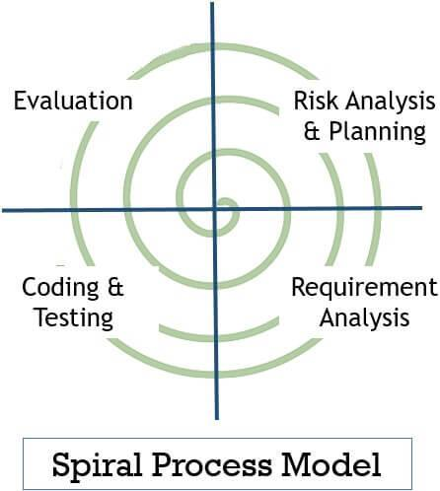

* 1. **Planning**

This phase includes the planning process, tasks, resource defining, team planning, timelines and gathering of other project related information. Planning phase includes the estimating costs, schedule for iteration. Once the planning finalizes the team proceed to the next step i.e., Risk Analysis.

* 1. **Risk Analysis**

In Risk Analysis phase, the project prototype is put up for the solution. All the planning which is being planned in the planning phase proceeds with the risk analysis phase to overcome the problems and risks at the beginning stage of project development. Technical and management risk are the factors that are included in the risk analysis phase.

* 1. **Engineering & Execution**

In this phase, the execution part is being done by engineers and developers. The planning and risk analysis once finalized is being processed in the execution phase where all the coding, testing and deploying of software takes place.

* 1. **Evaluation**

In the evaluation phase, the product is being assessed by the client and provided with the revert if any changes required from client side. Evaluation phase includes all the above phases whether it is about planning, risk analysis, engineering & execution the client goes through each phase for evaluating the product or software.

## **Quality Management**

Approach to Improve Project Quality and Achieve Quality Objectives

Quality management is a critical aspect of project success, ensuring that deliverables meet or exceed stakeholder expectations. Below outlines the approach that will be applied to enhance project quality and achieve the established quality objectives:

**1. Define Quality Objectives:**

* Begin by clearly defining specific and measurable quality objectives for the project. This involves collaborating with stakeholders to understand their expectations and establishing benchmarks that will signify successful project delivery.

**2. Comprehensive Quality Planning:**

* Develop a robust quality management plan that outlines the processes, methodologies, and standards that will be followed throughout the project lifecycle. This plan should encompass quality assurance (QA) and quality control (QC) activities, ensuring a proactive approach to quality management.
* Risk-Based Quality Management:

Implement a risk-based quality management approach that identifies potential risks to project quality early in the planning phase. This involves conducting risk assessments and developing mitigation strategies to address any anticipated challenges that may impact the project's quality.

**3. Continuous Monitoring and Measurement:**

* Establish a system for continuous monitoring and measurement of project processes and deliverables. Implement key performance indicators (KPIs) to track progress against quality objectives, allowing for timely identification and resolution of any deviations from the planned quality standards.

**4. Quality Assurance Reviews:**

* Conduct regular quality assurance reviews to assess adherence to established quality processes and standards. These reviews should be performed by qualified personnel and may include both internal and external audits to ensure objectivity.

**5. Stakeholder Communication:**

* Foster open communication with stakeholders regarding quality objectives, progress, and any adjustments to the quality management plan. This ensures that expectations are aligned, and any changes in project scope or quality criteria are communicated promptly.

**6. Employee Training and Development:**

* Invest in the training and development of project team members to enhance their understanding of quality standards and methodologies. A well-trained team is more likely to produce high-quality deliverables and adhere to established quality processes.

**7. Continuous Improvement:**

* Implement a culture of continuous improvement by encouraging feedback, lessons learned, and proactive identification of areas for enhancement. Regularly review and update the quality management plan based on lessons learned and changes in project requirements.

## **Training Plan**

**Training Plan for Git, ReactJS, and ASP.Net/C#**

**Overview:**

This training plan is designed to help individuals or groups of learners develop and enhance their skills in three crucial areas: Git, ReactJS, and C#. The plan includes several specific sections to ensure that learners have the opportunity to learn and practice each skill.

*Part I: Learning Git*

1. Objective: Understand how to use the Git version control system to manage project source code.
2. Content:

* Introduction to Git and basic concepts.
* Creating repositories and making commits.
* Branch management and merging in Git.
* Resolving conflicts in Git.
* Working with remote repositories.

*Part II: Learning ReactJS*

1. Objective: Develop the ability to build web applications using ReactJS.
2. Content:

* Introduction to ReactJS and fundamental concepts.
* Building React components.
* Managing state and props.
* Communicating with APIs and integrating data.
* Creating user interfaces with React.

*Part III: Learning ASP.Net/C#*

1. Objective: Understand how to use the C# programming language to develop software applications.
2. Content:

* Introduction to C# and basic concepts.
* C# syntax and programming principles.
* Building basic applications using C#.
* Working with databases using Entity Framework.
* Object-oriented programming (OOP) concepts with C#.
* Practice and Assessment:

After each learning section, learners will practice by participating in real-world projects and exercises.

Assessment will be based on performance in completing projects and exercises, as well as practical knowledge and skills.

Estimated Duration: This plan may range from a few months to a year, depending on the learner's pace and the time they dedicate to learning.

## **Responsibility Assignments**

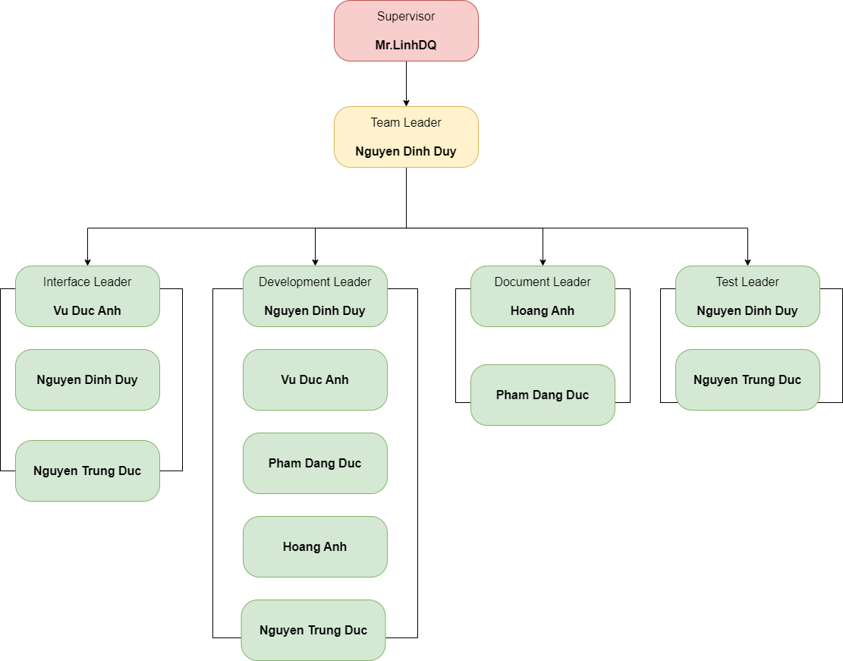

|  |  |  |  |
| --- | --- | --- | --- |
| **No** | **Name** | **Roles** | **Responsibilities** |
| **1** | **Nguyen Dinh Duy** | * Project Manager. * Technical Leader. * Development Team Le ader. | * Managed and lead the team project. * Analyzed and built materials for the project implementation process. * Developed project plan and implementation schedule. * Maintained an organization’s work flow and kept its lines of communication open. * Communicated with other members to guarantee the project was on schedule and within scope. * Reviewed and supported requirement analysis. * Researched algorithms and learned new techniques and architecture to use for projects. * Guided other members in the team to understand and to apply new techniques to the project. * Supported team members. |
| **2** | **Vu Duc Anh** | * Development Team Member * Design Team Leader | * Reviewed and supported requirement analysis. * Understood clearly about the project requirements and wrote SRS. * Identified certified solutions to meet the requirements. * Had a basic understanding of technology used for the project. * Guided other members to understand and to apply the technology to the project. * Summarized and made the project weekly report * Supported other team members. |
| **3** | **Hoang Anh** | * Development Team Member. * Design Team Member | * Had a basic understanding of technology used for the project. * Confirmed developing plan and assigned coding functions to other members. * Supported team in developing some functions. * Supported other team members. |
| **4** | **Nguyen Trung Duc** | * Development Team Member. * Test Team Member. * Document Team Member | * Had a basic understanding of technology used for the project. * Read & understand SRS and deploy document. * Optimized coding. * Executed testing. * Supported other team members. |
| **5** | **Pham Dang Duc** | * Test Team Leader. * Document Team leader. | * Supported requirement analysis. * Executed test cases, recorded test case results, documented and tracked defects, and performed test coverage analysis. * Supported team to develop some functions. |

## **Project Communications**

* Team meetings are held twice a week, on Wenesday and Saturday. Face-to-face meetings are the most effective way to understand requirements and communicate on the project. The outcomes of the meeting are the report of the completed and not completed work to improve and corresponding solutions for the project.
* All members will perform the task assigned by the leader on Thursday. On Monday, members will report what they have done in a week. After that, the team will work together to solve the problem and have plan for the coming week.
* **Communication Channels:**
* Email.
* Facebook.
* Phone.
* Face-to-face meetings
* Zalo
* **File Management:**
* Google Drive.
* Github

## **Project Work Plan**



## **Configuration Management**

## **Document Management**

* We manage project document by using Microsoft Word 2016
* Microsoft Word is an editing program that allows users to work on text documents with many effects such as fonts, text colors, graphic effects, multimedia effects, audio, video.
* Through Microsoft Word formatting tools, you can create professional quality documents effectively. Besides, Word also includes editing and revision tools that help you collaborate with people easily.
* Microsoft Word has the following functions: Drafting contracts and minutes; Drafting reports; Create CV; Create mail; Create envelopes; Watermark; Autocorrect; Document protection; Count from; Set display mode; …

## **Source Code Management**

* We manage project source code by using Git/GitHub
* **Manage source code easily**
* When you create a repo, the entire source code of that repo is saved on GitHub. Here, you can review your progress through comments after each commit. And the beauty here is that many people can make the same repo.
* The first benefit is that you know who committed and what. Next, your source can develop into many branches. Principles for working with branches like this: You can branch many branches to develop the project. But in the end, you have to merge back into the MASTER branch to get the complete project.
* **Tracking changes across versions**
* When there are many members working on a project, it is quite complicated to keep track of revisions - who changed what, when and where those files are stored. Don't worry because GitHub has taken this into account for you, by always saving the changes you push to the repository. Similar to Microsoft Word or Google Drive, you have a version history in case previous versions are lost or not saved.
* **Github is a great resource**
* With the Explore function, you can track and search for open source projects according to the technology pattern you like. Github supports code search regardless of whether it is a separate project or a website. In addition, this platform also has quite good SEO so users can search for any code string shared publicly.

## **Tools & Infrastructures**

* 1. **Tools**
* **Version Control Systems:** Git 2.13.0 or higher.
* **Source Code Management Systems:** GitHub.
* **Project Management Tools:** Microsoft Office 2016 (Word, Excel, PowerPoint).
* **Diagram Tools:** https://app.diagrams.net ( website ).
* **Design Tools:** Photoshop CC 2019.
* ETC….
  1. **Techniques**
* **Programming Language**
* ***English***
* ***Vietnamese***

# **Software Requirement Specification**

## **User Requirements**

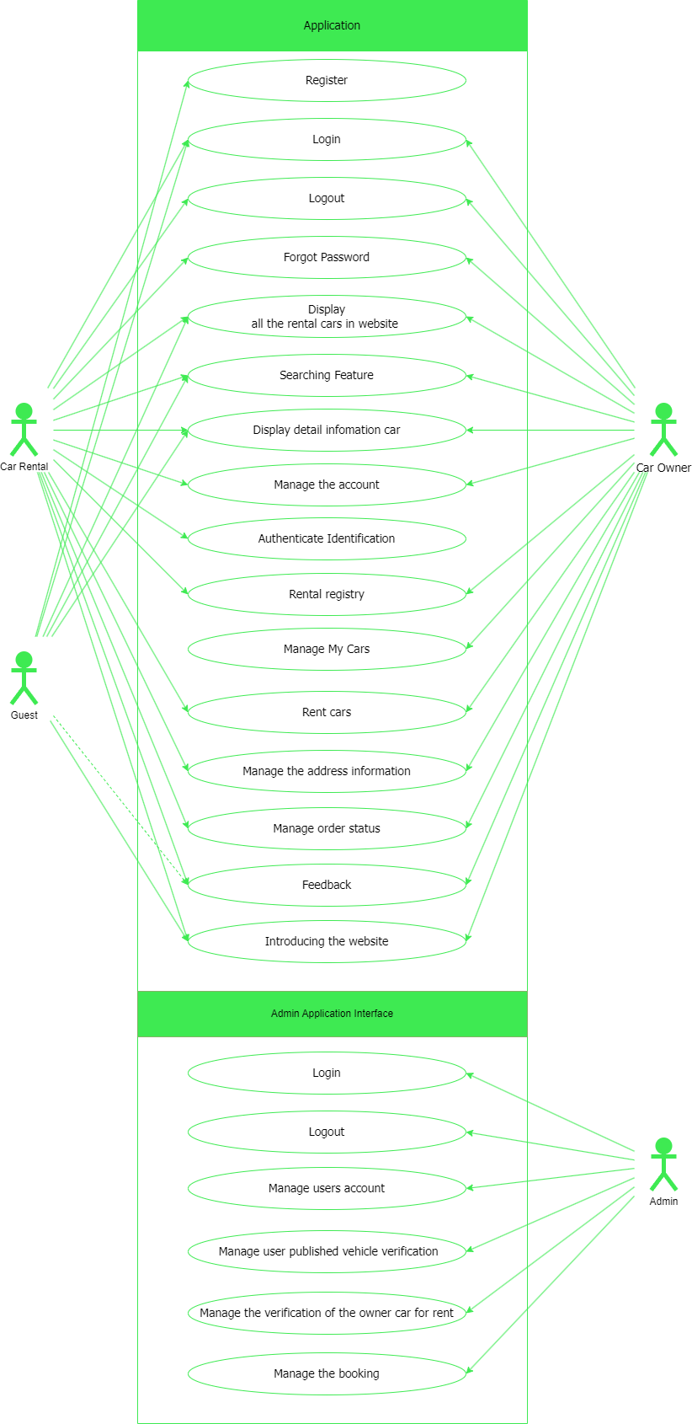

***FIRGURE 3.2.1.2*** *Use Case Diagram*

**UC-01 : Register:**

|  |  |
| --- | --- |
| **Use Case ID** | UC - 01 |
| **Use Case Name** | Register |
| **Actors** | Guest |
| **Description** | Register an account in the system. |
| **Pre-Condition** | * User is in login screen. * Internet permission |
| **Post-Condition** | * An account is registered. * Go to home screen. |
| **Trigger** | * Tap on “Sign Up” button. * Tap on email field. * Tap on name field. * Tap on password field. * Tap on “Register” button. |
| **Main flow** | |  |  | | --- | --- | | Actors | System | | 1.User click on “Sign Up” button |  | |  | 2. A resignter form will show up | | 3.User input form: Phonenum/Email, Name, Password, re-Password. Click and check box |  | |  | 4. The system updates user information -> adds the account to the database | | 5. Back to application interface |  | |
| **Alternative flow** | * When the user does not enter the required information in the registration form -> There are required fields that validated the user to fill in. * The “Confirm register” button will not available to click -> need to refresh the website |
| **Exception flow** | User enter not validated name, email or password. |
| **Business rule** | In order to log in to the system, user name and password are required. |

**UC-02: Login:**

|  |  |
| --- | --- |
| **Use Case ID** | UC – 02 |
| **Use Case Name** | Login |
| **Actors** | Guest, Registered User |
| **Description** | - This use case allows users who has username and password to login to the system to use system’s functions. Function that users can use must be allowed by admin.  - Allow user to login. |
| **Pre-Condition** | * User is in Home Screen * User have not logged in yet. * Internet permission. |
| **Post-Condition** | * Logged account. * Go to Home Screen. |
| **Trigger** | * Tap on “Login”. * User enters email/phonenum and passwords. * Tap on “Login” button. |
| **Main flow** | |  |  | | --- | --- | | Actors | System | | 1. Click on header - > “Sign in” button |  | |  | 2. Show “Login” screen with: Email, Password. | | 3. Enter email, password. Then, tap on “Sign In” button. |  | |  | 4. Show screen “Home Screen” with data of this account. | |
| **Alternative flow** | N/A |
| **Exception flow** | Not fill email and password to field or fill wrong email and password. |
| **Business rule** | In order to log in to the system, user name and password are required existed. |

**UC-03: Logout**

|  |  |
| --- | --- |
| **Use Case ID** | UC – 03 |
| **Use Case Name** | Logout |
| **Actors** | Registered User |
| **Description** | * This Usecase allows users who have logged in to the site to log out and delete data at the logged out device |
| **Pre-Condition** | * The user has logged in to the site successfully * Internet permission. |
| **Post-Condition** | * Account is logged out. * Do not save the account after the user logs out * Reload the page without the logged out user's data |
| **Trigger** | * Tap on user profile. * Tap on “Logout” button.   2.  - Click at arrow icon   * Tap on “Logout” button. |
| **Main flow** | |  |  | | --- | --- | | Actors | System | | 1. Click on header - > “profile” button |  | |  | 2. Show Manage profile screen | | 3. Click “logout” button |  | |  | 4. Delete the account on this device  5. Back to screen “Home screen” without data of user | |
| **Alternative flow** | N/A |
| **Exception flow** | N/A |
| **Business rule** | N/A |

**UC-04: Forgot password**

|  |  |
| --- | --- |
| **Use Case ID** | UC – 04 |
| **Use Case Name** | Forgot password |
| **Actors** | Car Owner, Car Rental |
| **Description** | * This Usecase allows the user to enter the registered information to reset the new password |
| **Pre-Condition** | * Getting login user failed. * Internet permission. * User at login screen |
| **Post-Condition** | * The user's account password is reset * User returns to login screen |
| **Trigger** | * Tap on “login” button * Click “Forgot password” * User enter “Username/Phonenum” to get SMS code * User enter SMS code * User enter new password and confirm new password |
| **Main flow** | |  |  | | --- | --- | | Actors | System | | 1. Click on header - > “Login” button |  | |  | 2. Show Login screen | | 3. Click “forgot password” button |  | |  | 4. Show Forgot password screen | | 5. Enter “Username/Phonenum” |  | |  | 6. Check Username/Phonenum validated with database.  7. Send SMS code to user’s phone. | | 8. User enter SMS code |  | |  | 9. Check SMS code validate.  10. Show reset password screen. | | 11. User enter new password.  12. User re-check pass word |  | |  | 13. Update new password to database.  14. Return to login screen | |
| **Alternative flow** | N/A |
| **Exception flow** | * The user filled in the wrong account name/phone number * The user entered the wrong SMS code |
| **Business rule** | To be able to reset the password. User's account must already exist |

**UC-05: Display all the rental cars in website :**

|  |  |
| --- | --- |
| **Use Case ID** | UC – 05 |
| **Use Case Name** | Display all the rental cars in website |
| **Actors** | All User, Guest |
| **Description** | * This Usecase allows the user to enter home screen website then show all the items in website |
| **Pre-Condition** | * Internet permission. |
| **Post-Condition** | * The user screen displays the website homepage and displays a list of rental cars. |
| **Trigger** | * User logs in to the site following the path |
| **Main flow** | |  |  | | --- | --- | | Actors | System | | 1. Tap the link, or website logo |  | |  | 2. Get product list from data  3. Show vehicle list on home page | |
| **Alternative flow** | N/A |
| **Exception flow** | N/A |
| **Business rule** | N/A |

**UC-06: Searching Feature :**

|  |  |
| --- | --- |
| **Use Case ID** | UC – 06 |
| **Use Case Name** | Searching Feature |
| **Actors** | All User |
| **Description** | * This Usecase allows users to look up and search for the desired product by filters or keywords |
| **Pre-Condition** | * Stable internet connection |
| **Post-Condition** | * Display a list of products that match user search results |
| **Trigger** | * The user on the home screen of the website.   The site has 2 data types for the search feature:   1. The user fills in the search bar with the keyword to be searched for. 2. Users choose tags that match their wants and needs |
| **Main flow** | |  |  | | --- | --- | | Actors | System | | 1. The user accesses the car rental service's website  2. Click on the search bar or select the card that suits the user's needs |  | |  | 3. The system displays the filters and tags of the product for users to select | | 4. User starts typing search criteria  5. User clicks "Search" icon to perform a search |  | |  | 4. The system conducts a search based on the criteria provided by the user.  5. The system displays search results on a separate page.  6. The results include a list of available rental cars and satisfy the search criteria. | |
| **Alternative flow** | 1. *No Results Found*  * After the user performs a search, the system does not find any results that match the search criteria. * The system displays a message to the user indicating that no results were found based on their search criteria. * The user may be advised to adjust their search criteria or try again with different values.  1. *Filtering Search Results*  * After viewing the list of search results, the user can choose to apply additional filters to narrow down the results. * They can filter by price, car type, brand, special features, and other criteria to customize the search results according to their preferences.  1. *Canceling Search*  * During the search process , the user may decide to cancel or go back to a previous step. The system provides options to cancel the current search and return to the main search page. |
| **Exception flow** | * Lost Internet Connection * Invalid Search Criteria * Database Error * Unspecified Search Error |
| **Business rule** | Valid Search Rules |

**UC-07: Display detail infomation car :**

|  |  |
| --- | --- |
| **Use Case ID** | UC – 07 |
| **Use Case Name** | Display detail infomation car |
| **Actors** | All User |
| **Description** | * Allow the user to view detailed information about a specific car on the car rental service's website |
| **Pre-Condition** | * Stable internet connection * The user has accessed the car rental service's website * The selected car for rental must exist in the system and have detailed information. |
| **Post-Condition** | * The user has viewed detailed information about the car for rental and can decide to continue with the booking process or return to the search page. |
| **Trigger** | * Users can access the vehicle list page * View a list of available rental vehicles and select a vehicle to view details * Click the "View Details" option or car image |
| **Main flow** | |  |  | | --- | --- | | Actors | System | | 1. The user selects a specific car from the search results or the car listing page |  | |  | 2. The system displays a car detail page for the selected car | | 3. The user can scroll down to view all the detailed car information or look at relevant images |  | |
| **Alternative flow** | N/A |
| **Exception flow** | * Lost Internet Connection * In the event that the car is no longer available or detailed information cannot be found, the system should display an error message and guide the user back to the search page. |
| **Business rule** | N/A |

**UC-08: Manage the account :**

|  |  |
| --- | --- |
| **Use Case ID** | UC – 08 |
| **Use Case Name** | Manage the account |
| **Actors** | Registered User |
| **Description** | * To allow users or account managers to perform account management activities, such as updating personal information, changing passwords, and managing account settings on the website |
| **Pre-Condition** | * Stable internet connection * The user has accessed the service's website and has logged into their account. * The account has been verified through a username and password or other authentication methods. |
| **Post-Condition** | * The user or account manager has completed account management activities and can return to using their account or perform other account management tasks. * Changes are stored and updated in the system. |
| **Trigger** | * Users successfully logs into their account * Tap on “Profile” icon * User Chooses Account Management Option * Users confirms saving their installation settings |
| **Main flow** | |  |  | | --- | --- | | Actors | System | | 1. User login successful  2. Accesses the account management section from the main interface. |  | |  | 3. Show “Profile” screen.  4. The system displays account management options for the user. | | 5. The user or account manager selects a specific option to proceed. |  | |  | 6. The system allows to update information.  7. save the changes and exit the account management page. | |
| **Alternative flow** | * Change Password: The user selects the "Change Password" option. They must provide the current password and then enter a new password. The system checks the validity of the new password and allows them to save the changes. * due to an expired login session, the system should redirect them back to the “profile” screen |
| **Exception flow** | * Lost Internet Connection * Invalid Password * Invalid Personal Information * Duplicate personal information * Authentication Failure |
| **Business rule** | N/A |

**UC-09: Authenticate Identification :**

|  |  |
| --- | --- |
| **Use Case ID** | UC – 09 |
| **Use Case Name** | Authenticate Identification |
| **Actors** | Registered User |
| **Description** | * This usecase to verify the identity of a user to ensure security and access rights. |
| **Pre-Condition** | * Stable internet connection * The user is attempting to access an account that requires identity authentication to be able to book a car rental |
| **Post-Condition** | * Successful authentication |
| **Trigger** | * Users successfully logs into their account * Tap on “Profile” icon or “Register to be owner” * Tap on “Identity authentication” * User enter ID, Name, DOB, images of ID * User confirm update. |
| **Main flow** | |  |  | | --- | --- | | Actors | System | | 1. User login successful  2. requires identity authentication. |  | |  | 3. The system requests authentication through the established authentication method | | 4. User enter ID, Name, DOB, images of ID |  | |  | 5. The system checks the provided authentication information valid  6. Checks information against stored data  7. To “Rental Register” screen. | |
| **Alternative flow** | N/A |
| **Exception flow** | * Lost Internet Connection * Authentication Failure * information is incorrect or does not match the stored data |
| **Business rule** | * The authentication process should adhere to legal and regulatory requirements, such as data protection laws and industry-specific standards |

**UC-10: Rental registry :**

|  |  |
| --- | --- |
| **Use Case ID** | UC – 10 |
| **Use Case Name** | Rental registry |
| **Actors** | Registered User |
| **Description** | * This Usecase for users to register an account as a car owner, rent a car |
| **Pre-Condition** | * Account logged in successfully * Account successfully verified for identification |
| **Post-Condition** | * The account has the right to publish rental cars, manage rental cars * Account granted vehicle owner rights |
| **Trigger** | * Users successfully logs into their account * Tap “Register to be owner” button * Tap on “Identity authentication” * User enter ID, Name, DOB, images of ID * User confirm update. * User enters car license plate number * Enter the parameters of the car and description for the vehicle * User taps next * Set your listing price * User uploads vehicle image as required by data * Confirm |
| **Main flow** | |  |  | | --- | --- | | Actors | System | | 1. User tap “Rental registry” button |  | |  | 2. Show “information vehical” form | | 3. The user enters all the required information. |  | |  | 4. Checks the provided information valid | | 5. Tap to confirm information of cars |  | |  | 6. Show “Set price” screen | | 7. Enter listing price |  | |  | 8. Check valid of price  9. Show “Set images” form | | 9. User set images of car  10. User enterVehicle registration/ vehicle inspection required |  | |  | 11. Verify that the vehicle details match the required data, which is preset  12. Database Duplicate Check  13. If the requirements are met, add the product to the product list  14. Display success notification panel | |
| **Alternative flow** | N/A |
| **Exception flow** | * Lost Internet Connection * Authentication Failure * No Vehicles Available * System Error |
| **Business rule** | * Vehicle Condition Report: A condition report is usually completed before and after each rental to document any pre-existing damage or issues with the vehicle. Customers are responsible for any new damage during the rental. * Insurance Coverage: required to have valid auto insurance coverage * Reasonable price with the quality of the car * The primary vehicle, owned by the registered owner. * The vehicle must be licensed and legally operable in accordance with the laws of the host country. |

**UC-11: Manage My Car :**

|  |  |
| --- | --- |
| **Use Case ID** | UC – 11 |
| **Use Case Name** | Manage My Car |
| **Actors** | Car Owner |
| **Description** | * This use case focuses on the actions related to managing the inventory of rental cars within a car rental service. It involves creating new car listings, deleting listings, editing existing listings, and updating information about rental cars. |
| **Pre-Condition** | * Must have the necessary access privileges and authentication to manage the rental car inventory. |
| **Post-Condition** | * New car listings are added to the inventory when created. * Deleted car listings are removed from the inventory. * Edited car listings are updated with the new information. * Updated car listings reflect any changes made to their information. * To ensure that the rental car inventory is up-to-date and accurate, providing customers with a selection of available cars to rent. |
| **Trigger** | * Users successfully logs into their account * Tap on “Profile” icon * Tap on “My cars” button/icon * Select the vehicle that the user wants to manage and modify |
| **Main flow** | |  |  | | --- | --- | | Actors | System | | 1. User tap “Profile” icon  2. Tap “My cars” Button |  | |  | 3. Show “Manage car” screen | | * Create Option:   4. Tap “Register new car” |  | |  | 5. The system prompts the user to input car details such as make, model, year, rental price, available dates, and other relevant information.  6. Once entered, the new car listing is added to the inventory. | | * Delete Option: | 7. The system displays a list of available car listings. | | 8. The car owner selects a car listing to delete. |  | |  | 9. A panel will show up to confirm delete  10. The selected car listing is removed from the inventory. | | * Edit Option:   11. The user selects a car listing to edit. |  | |  | 12. The system allows the administrator to make changes to the car's details  13. After the edits are made, the updated information is saved in the system. | |
| **Alternative flow** | * If there are errors in creating, deleting, editing, or updating a car listing, the system should provide appropriate error messages and allow the administrator to correct the issue. |
| **Exception flow** | * Lost Internet Connection * Unauthorized Access: If the account has not been registered as a vehicle owner, the 'Manage Cars' section will not appear |
| **Business rule** | * Only car owner can create new car listings. All required information, such as the make of the car, model, rental price, and availability dates, must be provided when creating a car listing. * Only car owner can delete car listings. The deletion process must be confirmed to prevent accidental deletion. * Only car owner can edit existing car listings. * The system should check for errors when administrators perform create, delete, edit, or update actions on car listings. Error messages and guidance for resolving errors should be provided when errors occur. |

**UC-12: Rent cars :**

|  |  |
| --- | --- |
| **Use Case ID** | UC – 12 |
| **Use Case Name** | Rent cars |
| **Actors** | Registered User |
| **Description** | * This use case defines the process of renting a car from a car rental service. Users (customers) have the ability to search for cars, choose a car type, make a reservation, provide payment information, and complete the rental. * Enable customers to conveniently and efficiently rent a car according to their needs. |
| **Pre-Condition** | * The customer has accessed the car rental service's system or website. * The customer has logged in and provided necessary authentication information (required). |
| **Post-Condition** | * The customer has completed the rental process and received confirmation. |
| **Trigger** | * Select car * Tap on “car detail” * Set rental times and dropoff times * Tap "Rent a car" * Confirm user’s information * Tap “Confirm rent” |
| **Main flow** | |  |  | | --- | --- | | Actors | System | | 1. The customer accesses the car rental service's system or website. |  | |  | 2. displays a list of available cars based | | 3. The customer selects the type of car they wish to rent  4. The customer views details about the car, including images and relevant information  5. The customer chooses the rental period and makes a reservation |  | |  | 6. The system requests payment information | | 7. The customer provides payment information |  | |  | 8. The system confirms the reservation and provides the customer with rental details.  9. Send SMS to the user | | 10. Enter Pin code to confirm rent |  | |  | 11. Check Pin code valid  12. The customer receives confirmation and booking details | |
| **Alternative flow** | * If the payment transaction fails, the system needs to inform the customer and offer options to retry or use an alternative payment method. |
| **Exception flow** | * Lost Internet Connection * If the customer wishes to cancel the reservation, they can do so before a specific rental period, following the car rental service's cancellation policy. * If a car experiences a breakdown or requires maintenance during the rental period, an error message will appear on the screen |
| **Business rule** | * A rule that specifies the duration of time for which a reservation is valid. For example, a reservation is valid for 4 hours before the start of the rental period. * Requires the system to verify the accuracy of payment information provided by the customer before confirming the reservation. * Customers must meet a minimum age requirement to rent a vehicle (e.g., typically 21 years or older), and there may be additional age-related rules or surcharges for younger drivers. * Customers are required to possess a valid driver's license to rent a vehicle. The license must be presented and verified during the rental process. * Customers may be required to have valid auto insurance coverage to rent a vehicle. The rental service may also offer insurance options. * Customers must provide a valid payment method (credit card, debit card, etc.) for security and payment purposes. Pre-authorization or security deposits may be required. * Customers must adhere to the specified return time, and late returns may incur additional charges. * The vehicle rental service must confirm and guarantee reservations based on availability. If the reserved vehicle is unavailable, an alternative of equal or better quality should be provided at the same rate. |

**UC-13: Manage the address information :**

|  |  |
| --- | --- |
| **Use Case ID** | UC – 13 |
| **Use Case Name** | Manage the address information |
| **Actors** | User |
| **Description** | * This use case describes the process of managing address information for users or other entities within a system or application. Users have the ability to add, edit, delete, and view address information. * Allow users to efficiently manage their address information |
| **Pre-Condition** | * The user has logged into their account within the system. |
| **Post-Condition** | * Address information has been added, edited, or deleted (if performed). |
| **Trigger** | * Tap “Profile” icon * Tap “Manage address” button |
| **Main flow** | |  |  | | --- | --- | | Actors | System | | 1. The user logs into their account  2. The user accesses the address information management section |  | |  | 3. Displays a list of existing address information | | 4. The user can perform the following actions   * Add Address * Edit Address * Delete Address |  | |  | 6. The system updates the address information after each action | |
| **Alternative flow** | * If the user does not have address information in the list, they can add the address they want to manage. * The user may choose not to take any action and only view the list of existing address information. |
| **Exception flow** | * If an error occurs when adding, editing, or deleting address information the system needs to notify the user and provide options to retry or contact support. |
| **Business rule** | * The user needs to enter the correct, existing address. |

**UC-14: Manage order status :**

|  |  |
| --- | --- |
| **Use Case ID** | UC – 14 |
| **Use Case Name** | Manage order status |
| **Actors** | Car Owner, Admin |
| **Description** | * This use case describes the process of managing the status of orders within a system. Users have the ability to change the status of an order, update relevant information, and view the current status. |
| **Pre-Condition** | * The user has logged into their account or the system with access to order status management. |
| **Post-Condition** | * Order status and related information have been updated. |
| **Trigger** | * Tap “Profile” icon * Tap “Rental Car Status” button * User Request: When a user actively navigates to the section of the system or application that allows them to manage order status, it triggers the use case * Update Order Information Request: When a user starts the process to update the detailed information of an order, it triggers the "Update Order Information" action within the use case. |
| **Main flow** | |  |  | | --- | --- | | Actors | System | | 1. The user logs into their account  2. The user accesses the order status management section |  | |  | 3. Displays a list of orders and their current status. | | 4. The user can change status |  | |  | 5. The system updates the status and order details | |
| **Alternative flow** | N/A |
| **Exception flow** | * Update Error: If an error occurs when the user updates the order status or order information, the system needs to report the error and provide options to retry or contact support.. |
| **Business rule** | N/A |

**UC-15: Feedback :**

|  |  |
| --- | --- |
| **Use Case ID** | UC – 15 |
| **Use Case Name** | Feedback |
| **Actors** | User or customer. |
| **Description** | * This use case describes the process of collecting and managing feedback from users or customers within a system or application. Users have the ability to submit feedback, rate, or report on their experience. * Allow users to provide feedback on a product or service to help improve its quality or address any issues that may arise. |
| **Pre-Condition** | * The user has experienced the product or service. * Internet is available. * User is in car detail screen |
| **Post-Condition** | * Feedback has been recorded and stored. |
| **Trigger** | * Guest: * Tap “vehicle details” * Go bottom * Show vehicle feedback and reviews * User: * submit feedback about service. * rating or score for service |
| **Main flow** | |  |  | | --- | --- | | Actors | System | | 1. The user experiences a product or service.  2. The user accesses the "Feedback" section |  | |  | 3. Displays an interface that allows the user to submit feedback or ratings.  4. The system stores the user's feedback, rating | |
| **Alternative flow** | N/A |
| **Exception flow** | N/A |
| **Business rule** | * Feedback Recording Rule: The system must record and store feedback to track and improve the product or service. * Feedback Security Rule: Security measures must be in place to protect user feedback information and ensure privacy. |

**UC-16: Introducing the website :**

|  |  |
| --- | --- |
| **Use Case ID** | UC – 16 |
| **Use Case Name** | Introducing the website |
| **Actors** | All User, Website Visitor |
| **Description** | * To access information about the organization, its mission, values, and team members. |
| **Pre-Condition** | * The user has internet access. * The user is on the website and navigates to the "About Us" section. |
| **Post-Condition** | * The user has a comprehensive understanding of the organization's background, mission, and key team members. |
| **Trigger** | * The user clicks on a specific link or button leading to the "About Us" section. |
| **Main flow** | |  |  | | --- | --- | | Actors | System | | 1. The user navigates to the "About Us" section through the website's footer. |  | |  | 2. Show detailed information about the organization's values, goals, and principles is presented. | |
| **Alternative flow** | N/A |
| **Exception flow** | * If there are technical issues loading the "About Us" page, there is a error site to report problems |
| **Business rule** | * The content in the "About Us" section should be regularly updated to reflect the latest information about the organization. * Visual elements should align with the organization's branding and contribute to a positive user experience. |

**UC-17: Manage users account :**

|  |  |
| --- | --- |
| **Use Case ID** | UC – 17 |
| **Use Case Name** | Manage users account |
| **Actors** | Admin |
| **Description** | * To manage and oversee user accounts for administrative purposes. |
| **Pre-Condition** | * The admin is logged into the admin dashboard |
| **Post-Condition** | * Changes made by the admin are reflected in the user accounts. |
| **Trigger** | * Admin tap “Account manage” button * Select a account to manage * Tap “Delete/Edit permission” |
| **Main flow** | |  |  | | --- | --- | | Actors | System | | 1. The user experiences a product or service.  2. The user accesses the "Feedback" section |  | |  | 3. Displays an interface that allows the user to submit feedback or ratings.  4. The system stores the user's feedback, rating | |
| **Alternative flow** | N/A |
| **Exception flow** | N/A |
| **Business rule** | * Feedback Recording Rule: The system must record and store feedback to track and improve the product or service. * Feedback Security Rule: Security measures must be in place to protect user feedback information and ensure privacy. |

**UC-18: Manage user published vehicle verification :**

|  |  |
| --- | --- |
| **Use Case ID** | UC – 18 |
| **Use Case Name** | Manage user published vehicle verification |
| **Actors** | Admin |
| **Description** | * This use case outlines the process of managing user account information within a system or application. |
| **Pre-Condition** | * The user is logged into the administrative account |
| **Post-Condition** | * User account information has been managed. |
| **Trigger** | * Guest: * Tap “vehicle details” * Go bottom * Show vehicle feedback and reviews * User: * submit feedback about service. * rating or score for service |
| **Main flow** | |  |  | | --- | --- | | Actors | System | | 1. The user experiences a product or service.  2. The user accesses the "Feedback" section |  | |  | 3. Displays an interface that allows the user to submit feedback or ratings.  4. The system stores the user's feedback, rating | |
| **Alternative flow** | N/A |
| **Exception flow** | N/A |
| **Business rule** | * Feedback Recording Rule: The system must record and store feedback to track and improve the product or service. * Feedback Security Rule: Security measures must be in place to protect user feedback information and ensure privacy. |

**UC-19: Manage the verification of the owner car for rent :**

|  |  |
| --- | --- |
| **Use Case ID** | UC – 19 |
| **Use Case Name** | Manage the verification of the owner car for rent |
| **Actors** | Admin |
| **Description** | * This use case outlines the process of managing user account information within a system or application. |
| **Pre-Condition** | * The user is logged into the administrative account |
| **Post-Condition** | * User account information has been managed. |
| **Trigger** | * Guest: * Tap “vehicle details” * Go bottom * Show vehicle feedback and reviews * User: * submit feedback about service. * rating or score for service |
| **Main flow** | |  |  | | --- | --- | | Actors | System | | 1. The user experiences a product or service.  2. The user accesses the "Feedback" section |  | |  | 3. Displays an interface that allows the user to submit feedback or ratings.  4. The system stores the user's feedback, rating | |
| **Alternative flow** | N/A |
| **Exception flow** | N/A |
| **Business rule** | * Feedback Recording Rule: The system must record and store feedback to track and improve the product or service. * Feedback Security Rule: Security measures must be in place to protect user feedback information and ensure privacy. |

**UC-20:**  **Manage the booking :**

|  |  |
| --- | --- |
| **Use Case ID** | UC – 20 |
| **Use Case Name** | Manage the booking |
| **Actors** | Admin |
| **Description** | * This use case outlines the process of managing user account information within a system or application. |
| **Pre-Condition** | * The user is logged into the administrative account |
| **Post-Condition** | * User account information has been managed. |
| **Trigger** | * Guest: * Tap “vehicle details” * Go bottom * Show vehicle feedback and reviews * User: * submit feedback about service. * rating or score for service |
| **Main flow** | |  |  | | --- | --- | | Actors | System | | 1. The user experiences a product or service.  2. The user accesses the "Feedback" section |  | |  | 3. Displays an interface that allows the user to submit feedback or ratings.  4. The system stores the user's feedback, rating | |
| **Alternative flow** | N/A |
| **Exception flow** | N/A |
| **Business rule** | * Feedback Recording Rule: The system must record and store feedback to track and improve the product or service. * Feedback Security Rule: Security measures must be in place to protect user feedback information and ensure privacy. |

## **Functional Requirements**

### System Functional Overview

*[Provide functionality overview of software system: screen flow, screen descriptions, system user roles, screen authorization, non-screen functions, ERD]*

# 3.2.1.1 Mockup

* **Screen: Application Interface**

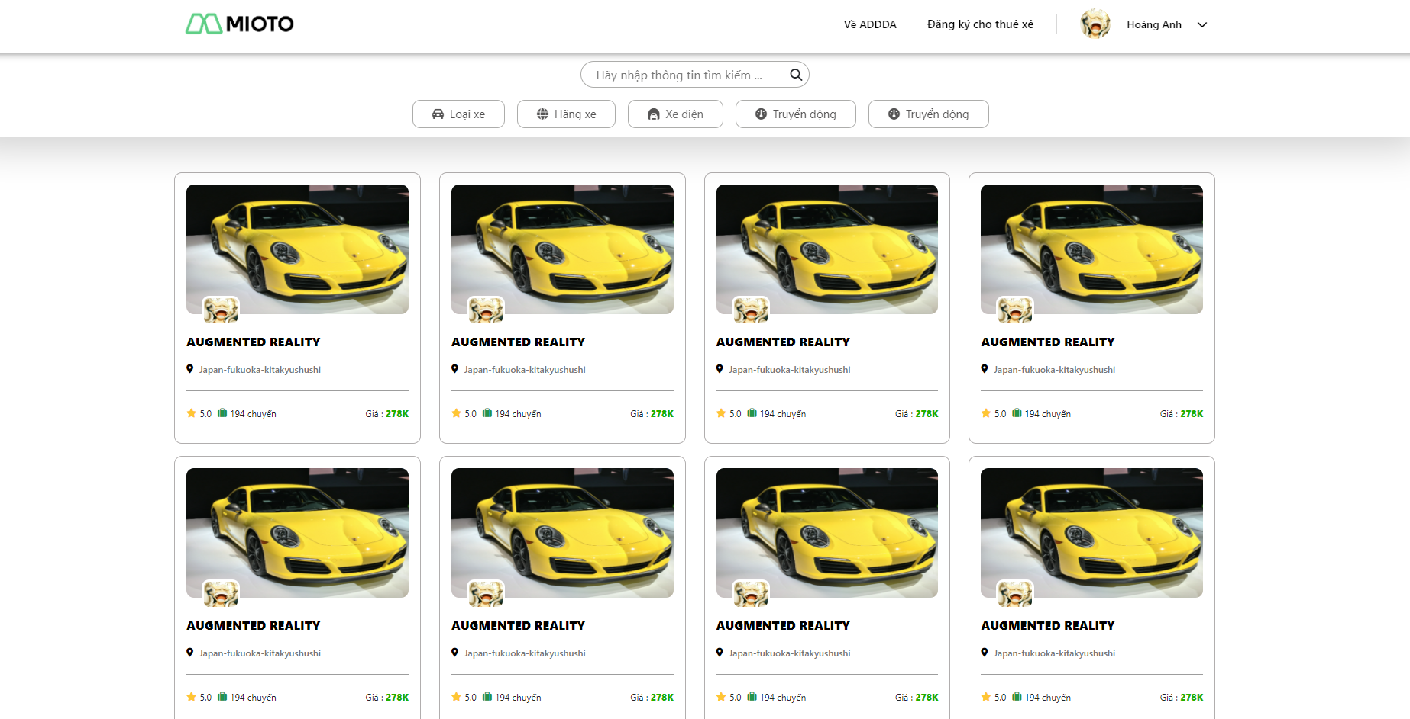

***FIRGURE* *3.2.1.1***

**Description:** The page displayed when users access the website via a URL. This is the website's homepage, featuring a list of the website's products. Users can view it whether they are logged in or not.

* **Screen: Login Form**

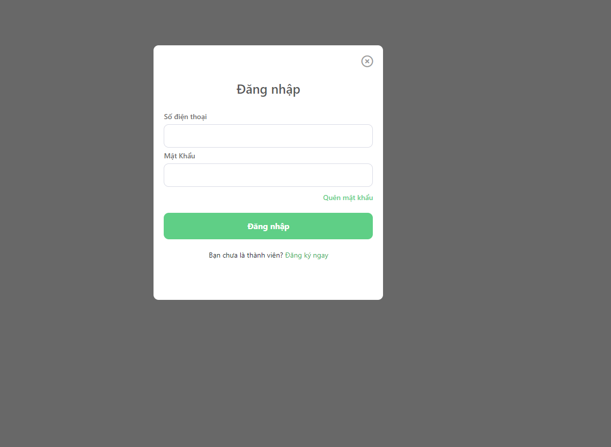

***FIRGURE* *3.2.1.2***

**Description:** Website's login form. Users who are not logged in, upon visiting the website, can click on the 'login' button located at the top right of the webpage to display this form.

* **Screen: Resignter Form**

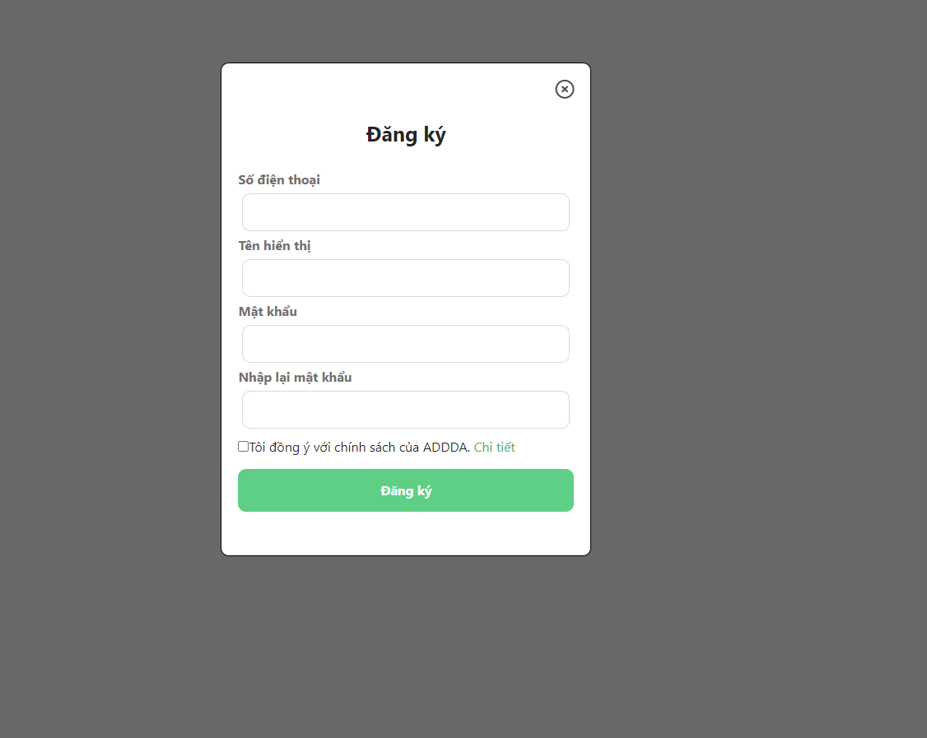

***FIRGURE* *3.2.1.3***

**Description:** The Account Registration Form is a part of the application or website designed for new users. It allows users to create an account to access the features and services of the application or website.

* **Screen: Profile**

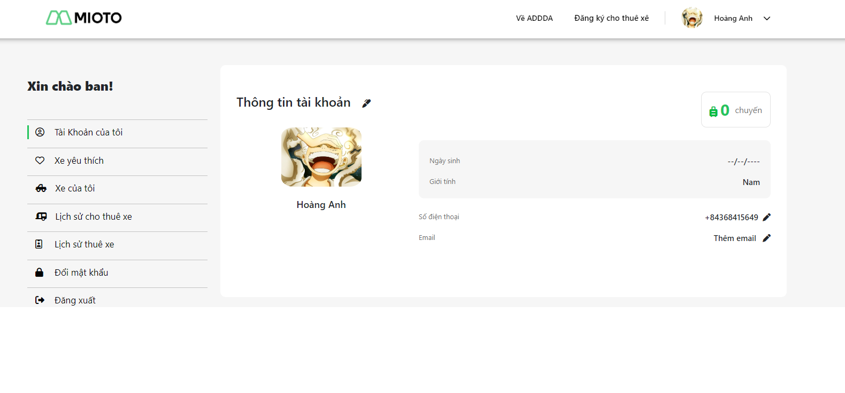

***FIRGURE* *3.2.1.4***

**Description:** User's Personal Information Management Page. From the homepage, users click on the 'profile' icon. The page displays information for editing, a logout button, and user-selected personal preferences.

* **Screen: Details Car**

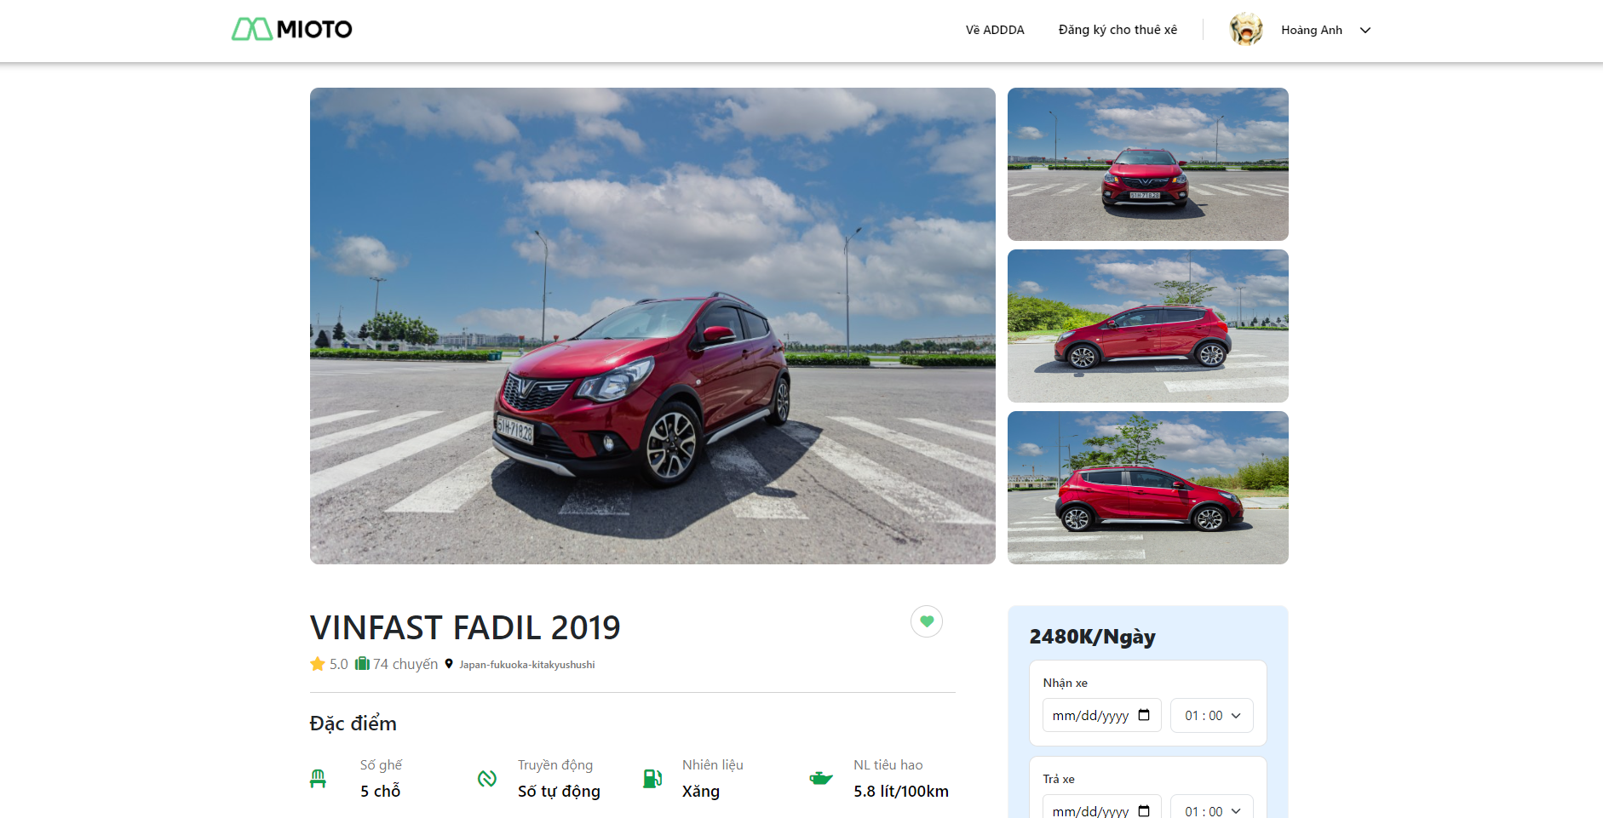

***FIRGURE* *3.2.1.5a***

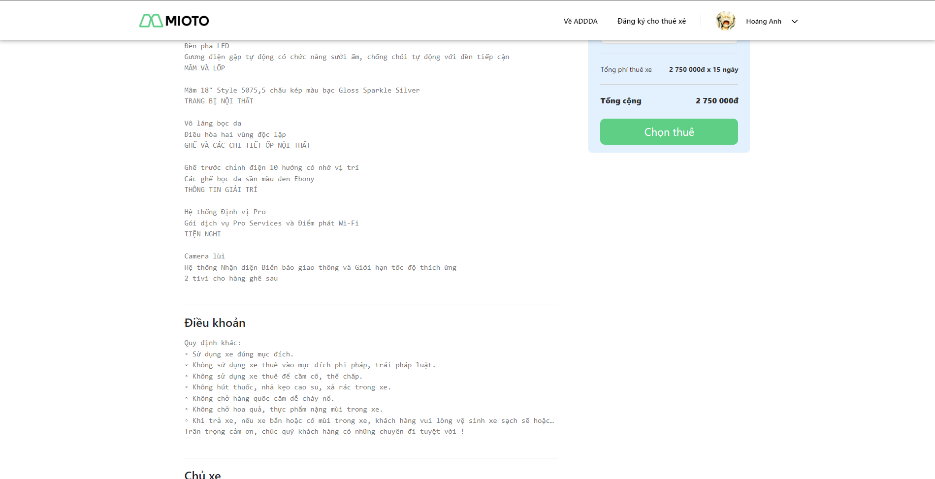

***FIRGURE* *3.2.1.5b***

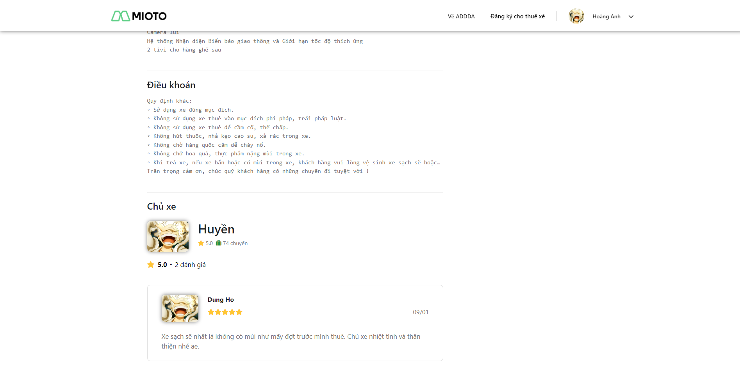

***FIRGURE* *3.2.1.5c***

**Description:** After clicking on the image or name of a rental car on the homepage, the system will display a detailed information page about the car, including (car description, features, owner, terms, etc.). Users can choose to make a reservation and rent the car.

Display feedback from users who have experienced this car.

## Non-Functional Requirements

### Reliability

-This is a communication website, so reliability is very important. The information from this website must be real and exactly (phone number, store address)

### Availability

Systems created using the platform should be generally available to users.

### 3.2.3.3 Security

The security is necessary for almost website. Protect user information is important

### Maintainability

The platform should contain interfaces that are extensible to allow new communication protocols to be added with ease.

### Portability

We can connect website by every device have internet

## Other Requirements…

# Software Design Description

*[Provide final software design information follow the template as part II in the Report #4]*

## 1. System Design

### 1.1 System Architecture

*[The content of this section includes the overall diagram which includes the sub-systems, the external systems, and the relationship/connection among them. You need also provide the explanation for each of the diagram components (modules, sub-systems, external systems, etc.)].*

### 1.2 Package Diagram

*[Provide the package diagram for each sub-system. The content of this section includes overall package diagram(s) and the explanation for each package (or namespace)]*

## 2. Database Design

4.2.2.1 Class Diagram

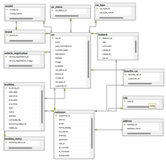

* **Table detail**
* **Table car**

|  |  |  |  |
| --- | --- | --- | --- |
| **Column** | **Data type** | **Constraint** | **Description** |
| car_id | Integer | -primary key  -unsigned | Car id |
| price | Float |  | Car price |
| year_manufacture | Integer |  | Year of car’s manufacture |
| image | Varchar(255) |  | Car image |
| is_delete | Integer |  | car status info |
| number_plate | Varchar(255) |  | Car number plate |
| description | Text |  | Car description |
| Address | Varchar(225) |  | Car address |
| custumer_id | Integer |  | Custumer id |
| brand_id | Integer |  | Car brand id |
| Model_id | Integer |  | Car model id |
| car_type_id | Integer |  | Car type id |
| car_status_id | Integer |  | Car status id |

* **Table customer**

|  |  |  |  |
| --- | --- | --- | --- |
| **Column** | **Data type** | **Constraint** | **Description** |
| custumer_id | Integer | -primary key  -unsigned | Custumer id |
| phone | Varchar(50) |  | Custumer phone number |
| email | Varchar(255) |  | Custumer email address |
| name_display | Varchar(50) |  | Custumer name display on system |
| full_name | Varchar(50) |  | Custumer full name |
| birthday | Varchar(255) |  | Custumer birthday |
| password | Varchar(50) |  | Custumer account password |
| role_name | String |  | Custumer role |
| id_number | Varchar(255) |  | Custumer national id |
| id_fontside | Varchar(255) |  | Custumer national id fontside |
| id_backside | Varchar(255) |  | Custumer national id backside |
| Verify_flg | Integer |  | Verify status |

* **Table booking**

|  |  |  |  |
| --- | --- | --- | --- |
| **Column** | **Data type** | **Constraint** | **Description** |
| booking_id | Varchar(20) | -primary key  -unsigned | Booking id |
| start_date | Varchar(20) |  | Booking start date |
| start_time | Varchar(20) |  | Booking start time |
| end_date | Varchar(20) |  | Booking end date |
| end_time | Varchar(20) |  | Booking end time |
| Total | Integer |  | Booking total |
| Complete_flg | Integer |  | Booking status |
| status_id | Intger |  | Booking status id |
| create_by | Integer |  | Booking create by |
| car_id | Integer |  | Car id |

* **Table feedback**

|  |  |  |  |
| --- | --- | --- | --- |
| **Column** | **Data type** | **Constraint** | **Description** |
| feedback_id | Integer | -primary key  -unsigned | Feedback id |
| rate | Integer |  | Feedback star rate |
| comment | Text |  | Feedback content |
| create_at | Varchar(20) |  | Feedback create at |
| create_by | Integer |  | Feedback create by |
| car_id | integer |  | Car id |

* **Table favourite_car**

|  |  |  |  |
| --- | --- | --- | --- |
| **Column** | **Data type** | **Constraint** | **Description** |
| favourite_car_id | integer | -primary key  -unsigned | Favourite car id |
| custumer_id | Integer |  | Custumer id |
| car_id | Integer |  | Car id |

* **Table address**

|  |  |  |  |
| --- | --- | --- | --- |
| **Column** | **Data type** | **Constraint** | **Description** |
| address_id | integer | -primary key  -unsigned | Address id |
| address_name | Varchar(255) |  | Address name |
| customer_id | integer |  | Custumer id |

* **Table booking_status**

|  |  |  |  |
| --- | --- | --- | --- |
| **Column** | **Data type** | **Constraint** | **Description** |
| booking_status_id | Integer | -primary key  -unsigned | Booking status id |
| Booking_status_name | Varchar (50) |  | Booking status name |

* **Table car_status**

|  |  |  |  |
| --- | --- | --- | --- |
| **Column** | **Data type** | **Constraint** | **Description** |
| car_status_id | Integer | -primary key  -unsigned | Car status id |
| car_status_name | Varchar (50) |  | Car status name |

* **Table brand**

|  |  |  |  |
| --- | --- | --- | --- |
| **Column** | **Data type** | **Constraint** | **Description** |
| Brand_id | Integer | -primary key  -unsigned | Brand id |
| Brand_name | Varchar (255) |  | Brand name |

* **Table model**

|  |  |  |  |
| --- | --- | --- | --- |
| **Column** | **Data type** | **Constraint** | **Description** |
| model_id | Integer | -primary key  -unsigned | Model id |
| model_name | Varchar(255) |  | Model name |
| brand_id | Integer |  | Brand id |

* **Table vehicle_registration**

|  |  |  |  |
| --- | --- | --- | --- |
| **Column** | **Data type** | **Constraint** | **Description** |
| vehicle_registration_id | Integer | -primary key  -unsigned | Vehicle registration id |
| vehicle_registration_image | Varchar(255) |  | Vehicle registration image |
| vehicle_inspection_image | Varchar(255) |  | Vehicle inspection image |
| car_id | Integer |  | Car id |

* **Table car_type**

|  |  |  |  |
| --- | --- | --- | --- |
| **Column** | **Data type** | **Constraint** | **Description** |
| car_type_id | Integer | -primary key  -unsigned | Car type id |
| car_type_name | Varchar(255) |  | Car type name |
| number_seats | Integer |  | Car number seats |

*[Provide the files description, database table relationship & table descriptions]*

## 3. Detailed Design

### 3.1 <Sequence Diagram>

*[Provide the detailed design for the feature <Feature Name1>. It includes Class Diagram, Class Specifications, and Sequence Diagram(s);* ***For the features/functions with the same structure of class & sequence diagrams, you need to provide the diagrams once for one feature/function and refer to those diagrams from other features/functions****]*

***4.3.1.1 <Sequence diagram for Use case “Register”>***

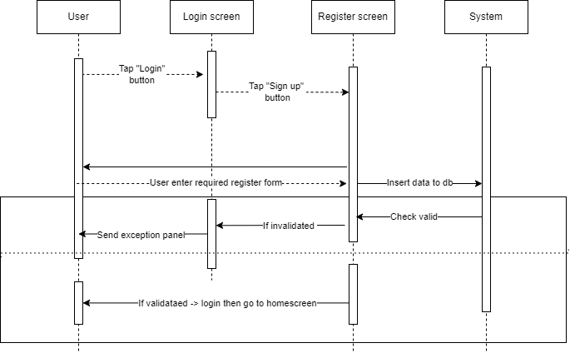

***4.3.1.2 <Use case “Login”>***

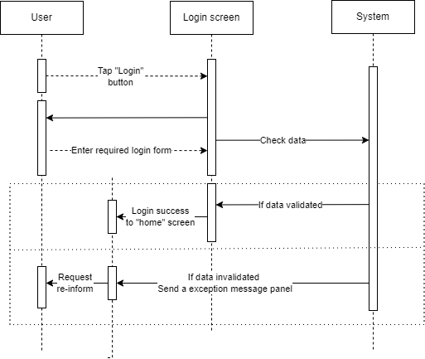

***4.3.1.3 < Sequence diagram for Use case “Logout”>***

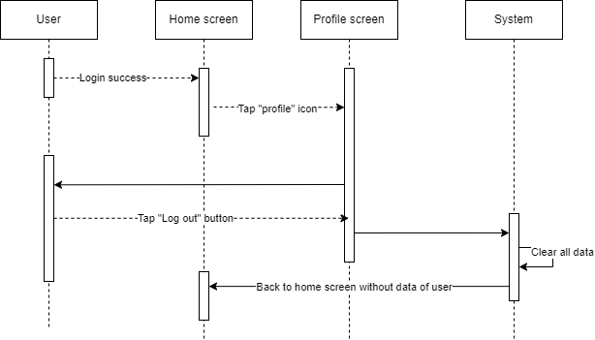

***4.3.1.4 < Sequence diagram for Use case “Forgot password”>***

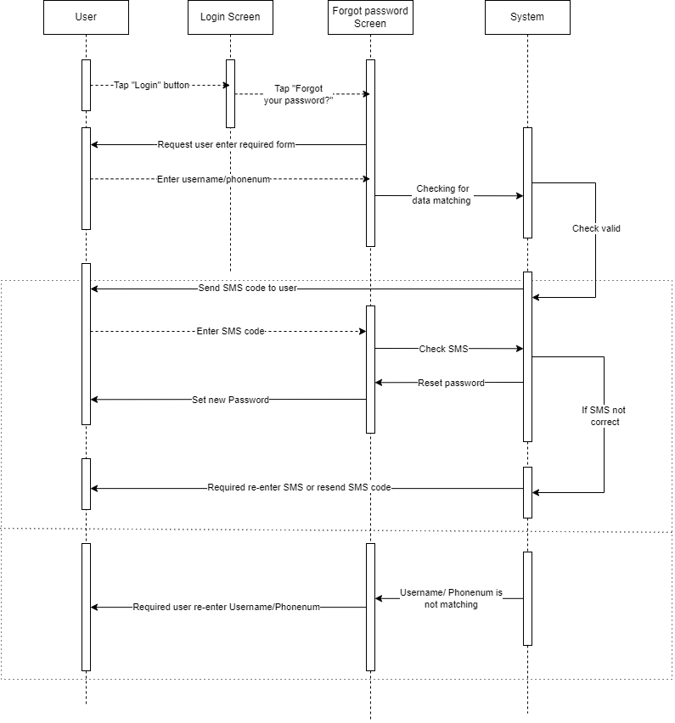

***4.3.1.5 < Sequence diagram for Use case “Display all the rental cars in website”>***

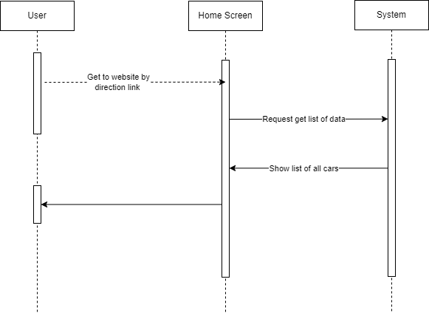

***4.3.1.6 < Sequence diagram for Use case “Searching Feature”>***

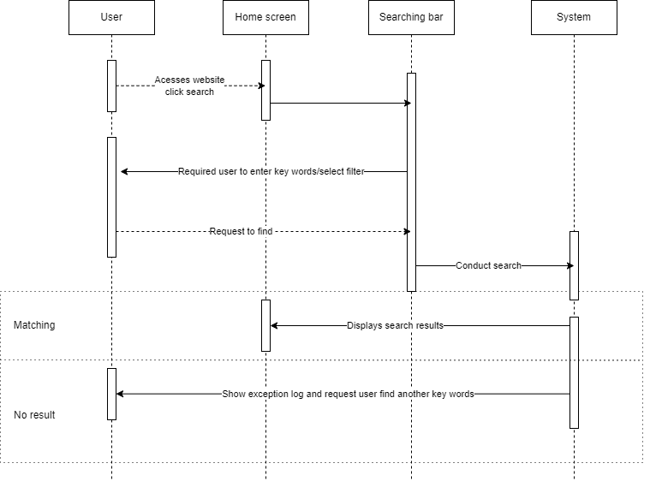

***4.3.1.7 < Sequence diagram for Use case “Display detail information car”>***

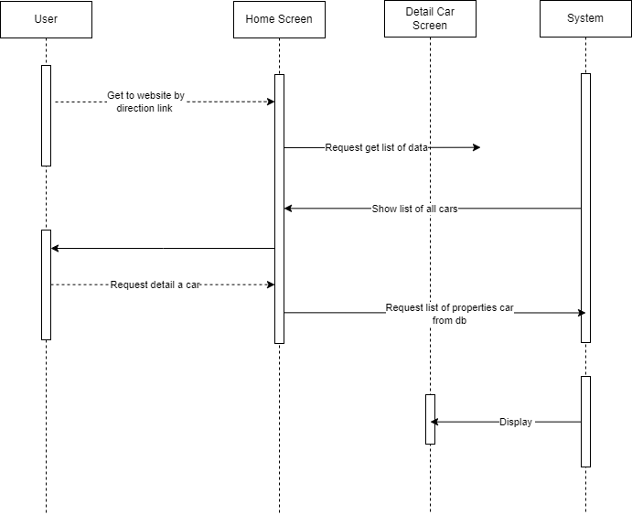

***4.3.1.8 < Sequence diagram for Use case “Manage the account”>***

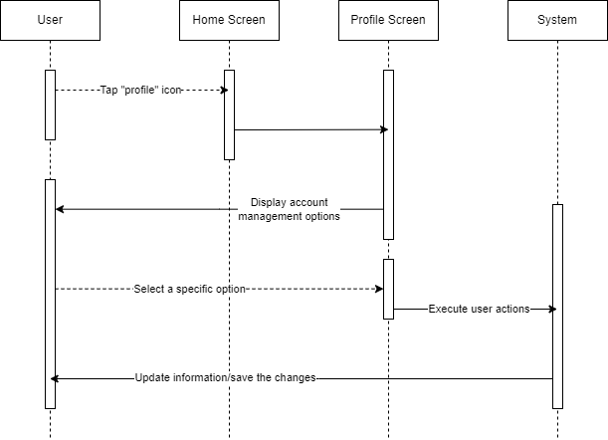

***4.3.1.9 < Sequence diagram for Use case “Authenticate Identification”>***

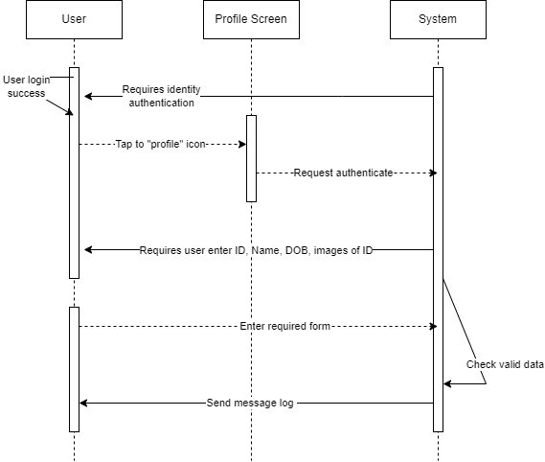

***4.3.1.10 < Sequence diagram for Use case “Rental Registry”>***

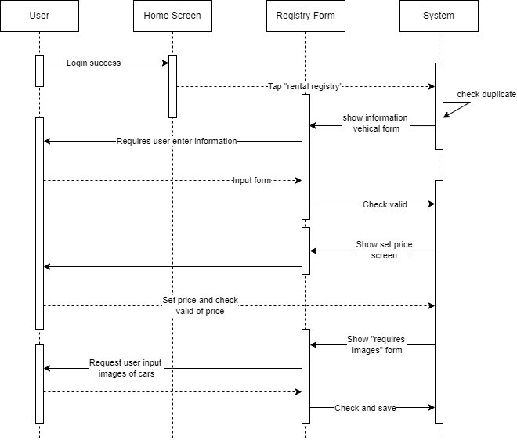

***4.3.1.11 < Sequence diagram for Use case “Create/Delete/Edit/Update for rental cars”>***

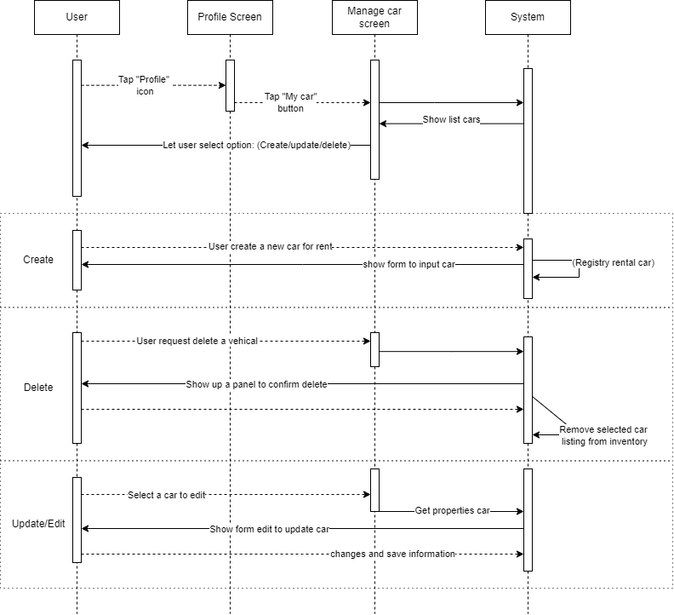

***4.3.1.12 < Sequence diagram for Use case “Rent cars”>***

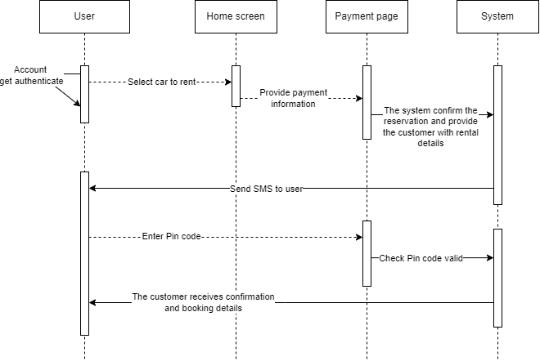

***4.3.1.13 < Sequence diagram for Use case “Manage the address information”>***

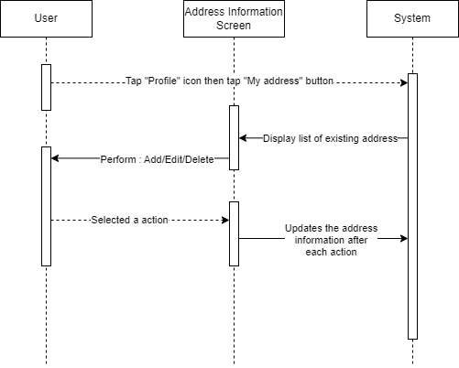

***4.3.1.14 < Sequence diagram for Use case “Manage order status”>***

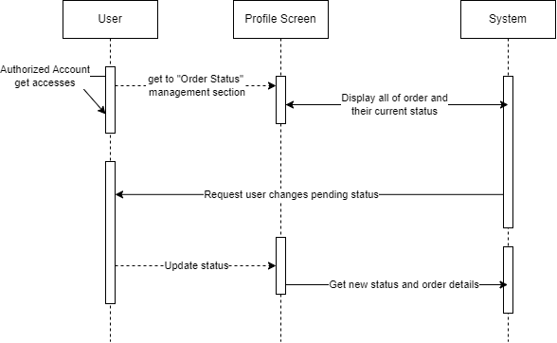

### 3.2 <Feature/Function Name2>

# Software Testing Documentation

*[Provide final software testing information follow the template as part II in the Report #5]*

## 1. Scope of Testing

*[Describe the scopes of the test. Those include the target-of-test’s features, functions, and non-functional requirements that will or will not be tested.*

*Describe the stages/levels of testing that would be applied to your project - Unit, Integration, or System test. Each includes the in-charge, inputs/time, focuses, acceptance criteria.*

*List any constraints or assumptions made during the development of this document that may impact the design, development or implementation of testing]*

## 2. Test Strategy

*[List out and describe all testing types (you can refer the test types listed below or any other test types to selected the suitable ones for the project; for each selected test types you need to provide the following information: test objective, technique, completion criteria, etc.), test levels that those test types would be performed, & the details of test supporting tools would be used in the project]*

### 2.1 Testing Types

*[List out and describe here the testing types which you would apply in your project. You need to mention following information for each type of testing: objective, technique, completion criteria]*

### 2.2 Test Levels

*<List out and describe here the testing levels which you would execute in your project. Besides, clearly state the test types which are performed in each test level that you plan for this project>*

### 2.3 Supporting Tools

*<List of the test supporting tools which will be employed for this project>*

## 3. Test Plan

### 3.1 Human Resources

*[List and provide the details on roles and responsibilities of the project members who would involve in testing works]*

### 3.2 Test Environment

*[List and provide the details about the tools (software, hardware, infrastructure) which the project would use for testing]*

### 3.3 Test Milestones

*[Separate test milestones, which should be identified to communicate project status accomplishments]*

## 4. Test Cases

*[Prepare the details on the test cases following the provided template*

* *Unit Test Cases: Report5_Unit Test.xls*
* *Other Test Cases (IT, ST, AT): Report5_Test Report.xls]*

## 5. Test Reports

*[Provide the test result, statistics and the relevant test analysis for your testing in the project]*

# Release Package & User Guides

*[Provide final software testing information follow the template as part II in the Report #6]*

## 1. Deliverable Package

*[The section will list all source programs, scripts, documents with version number in this release. You can see the example following table for reference, can customize or delete if not using belong to each project characteristics]*

| **No.** | **Deliverable Item** | **Description** |
| --- | --- | --- |
| 1 | Schedule/Task Tracking |  |
| 2 | Project Backlog |  |
| 3 | Source Codes |  |
| 4 | Database Script(s) |  |
| 5 | Final Report Document |  |
| 6 | Test Cases Document |  |
| 7 | Defects List |  |
| 8 | Issues List |  |
| 9 | Slide |  |

## 2. Installation Guides

### 2.1 System Requirements

*[Define any system requirements necessary to support the application, including the software and relevant configurations]*

### 2.2 Installation Instruction

*[Includes installation instructions and configuration guidelines]*

## 3. User Manual

### 3.1 Overview

*[Descript the overview of the application and if could, insert the features workflow to help user has the overview of all the features in this application]*

### 3.2 Workflow 1

*[Describe the purpose of this workflow, draw workflow diagram and other relevant diagrams]*

*[Describe the detailed guides for the workflow by providing the brief description, step by step guides (attached with user interface) of how to use that function]*

### 3.3 Workflow 2